NUGRAHA RAHARJA - TECHNICAL TEST – .NET Developer

**.**

a.

USE [TechnicalTest]

GO

/****** Object: Table [dbo].[TBL_EMPL] Script Date: 11/23/2023 10:30:43 AM ******/

SET ANSI_NULLS ON

GO

SET QUOTED_IDENTIFIER ON

GO

CREATE TABLE [dbo].[TBL_EMPL](

[EMPLOYEE_ID] [int] IDENTITY(1,1) NOT NULL,

[EMPLOYEE_NAME] [nvarchar](max) NULL,

[AGE] [int] NULL

) ON [PRIMARY] TEXTIMAGE_ON [PRIMARY]

GO

CREATE TABLE [dbo].[TBL_EMPL_DEPT](

[EMPLOYEE_ID] [int] NULL,

[DEPARTEMENT_ID] [int] NULL

) ON [PRIMARY]

GO

CREATE TABLE [dbo].[TBL_EMPL_DEPT](

[EMPLOYEE_ID] [int] NULL,

[DEPARTEMENT_ID] [int] NULL

) ON [PRIMARY]

GO

--B

SELECT * FROM TBL_EMPL WHERE AGE < 45

--C

SELECT A.*, C.DEPARTMENT_NAME FROM TBL_EMPL A

INNER JOIN TBL_EMPL_DEPT B ON A.EMPLOYEE_ID = B.EMPLOYEE_ID

INNER JOIN TBL_DEPT C ON B.DEPARTEMENT_ID = C.DEPARTMENT_ID

WHERE C.DEPARTMENT_NAME = 'Animation'

--D

SELECT A.*, C.MINIMUM_SALARY FROM TBL_EMPL A

INNER JOIN TBL_EMPL_DEPT B ON A.EMPLOYEE_ID = B.EMPLOYEE_ID

INNER JOIN TBL_DEPT C ON B.DEPARTEMENT_ID = C.DEPARTMENT_ID

WHERE C.MINIMUM_SALARY < 4000000

1. –

using System;

namespace HelloWorld

{

class Program

{

static void Main(string[] args)

{

var angka = 1;

var num = 0;

var outx = "";

var ning = 20;

for (int i = 0; i < ning; i++)

{

if ((i%5==0)&&(i!=5))

{

outx = outx + "AERO";

}

else if ((i%6==0)&&(i!=6))

{

outx = outx + "ASYST";

}

else

{

outx = outx + i;

}

}

Console.WriteLine("Output :"+outx);

}

}

}

1. –

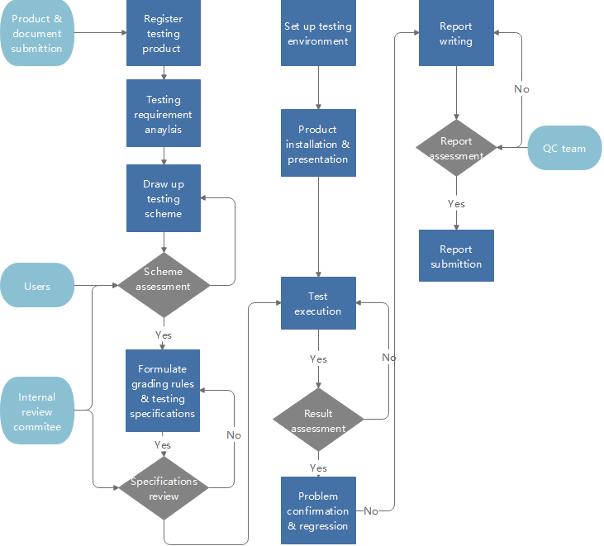

B. 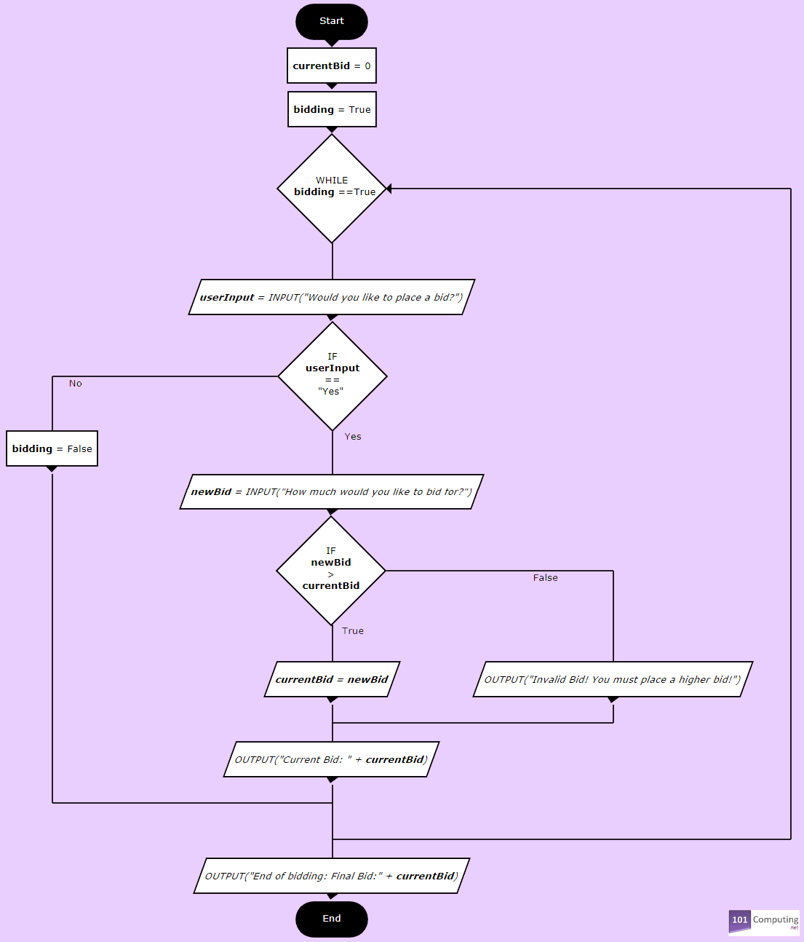

1. –

a.

USE [TechnicalTest]

GO

/****** Object: Table [dbo].[product] Script Date: 11/23/2023 11:29:31 AM ******/

SET ANSI_NULLS ON

GO

SET QUOTED_IDENTIFIER ON

GO

CREATE TABLE [dbo].[product](

[id] [int] IDENTITY(1,1) NOT NULL,

[nama_barang] [varchar](200) NOT NULL,

[kode_barang] [varchar](50) NOT NULL,

[jumlah_barang] [int] NOT NULL,

[tanggal] [datetime] NOT NULL

) ON [PRIMARY]

GO

b. –

-- ================================================

-- Template generated from Template Explorer using:

-- Create Procedure (New Menu).SQL

--

-- Use the Specify Values for Template Parameters

-- command (Ctrl-Shift-M) to fill in the parameter

-- values below.

--

-- This block of comments will not be included in

-- the definition of the procedure.

-- ================================================

SET ANSI_NULLS ON

GO

SET QUOTED_IDENTIFIER ON

GO

-- =============================================

-- Author: <Author,,Name>

-- Create date: <Create Date,,>

-- Description: <Description,,>

-- =============================================

CREATE PROCEDURE INSERT_PRODUCT

-- Add the parameters for the stored procedure here

@KODE_BARANG varchar(50),

@NAMA_BARANG varchar(200),

@JUMLAH_BARANG int

AS

BEGIN

INSERT INTO [dbo].[product]

([nama_barang]

,[kode_barang]

,[jumlah_barang]

,[tanggal])

VALUES

(@NAMA_BARANG

,@KODE_BARANG

,@JUMLAH_BARANG

,getdate())

END

GO

USE [TechnicalTest]

GO

CREATE PROCEDURE UPDATE_PRODUCT

-- Add the parameters for the stored procedure here

@KODE_BARANG varchar(50),

@JUMLAH_BARANG int

AS

BEGIN

UPDATE [dbo].[product]

SET

[jumlah_barang] = @JUMLAH_BARANG

,[tanggal] = getdate()

WHERE kode_barang = @KODE_BARANG

END

GO

USE [TechnicalTest]

GO

CREATE PROCEDURE DELETE_PRODUCT

-- Add the parameters for the stored procedure here

@KODE_BARANG varchar(50)

AS

BEGIN

DELETE FROM [dbo].[product]

WHERE kode_barang = @KODE_BARANG

END

GO

USE [TechnicalTest]

GO

CREATE PROCEDURE SEARCH_PRODUCT

-- Add the parameters for the stored procedure here

@KODE_BARANG varchar(50)

AS

BEGIN

SELECT [id]

,[nama_barang]

,[kode_barang]

,[jumlah_barang]

,[tanggal]

FROM [dbo].[product]

WHERE kode_barang = @KODE_BARANG

END

GO

c.

Imports System

Imports System.Collections.Generic

Imports System.Data

Imports System.Data.Entity

Imports System.Linq

Imports System.Net

Imports System.Web

Imports System.Web.Mvc

Imports Technical

Namespace Controllers

Public Class productsController

Inherits System.Web.Mvc.Controller

Private db As New TechnicalTestEntities

' GET: products

Function Index() As ActionResult

Return View(db.products.ToList())

End Function

' GET: products/Details/5

Function Details(ByVal id As Integer?) As ActionResult

If IsNothing(id) Then

Return New HttpStatusCodeResult(HttpStatusCode.BadRequest)

End If

Dim product As product = db.products.Find(id)

If IsNothing(product) Then

Return HttpNotFound()

End If

Return View(product)

End Function

' GET: products/Create

Function Create() As ActionResult

Return View()

End Function

' POST: products/Create

'To protect from overposting attacks, enable the specific properties you want to bind to, for

'more details see https://go.microsoft.com/fwlink/?LinkId=317598.

<HttpPost()>

<ValidateAntiForgeryToken()>

Function Create(<Bind(Include:="id,nama_barang,kode_barang,jumlah_barang,tanggal")> ByVal product As product) As ActionResult

If ModelState.IsValid Then

db.products.Add(product)

db.SaveChanges()

Return RedirectToAction("Index")

End If

Return View(product)

End Function

' GET: products/Edit/5

Function Edit(ByVal id As Integer?) As ActionResult

If IsNothing(id) Then

Return New HttpStatusCodeResult(HttpStatusCode.BadRequest)

End If

Dim product As product = db.products.Find(id)

If IsNothing(product) Then

Return HttpNotFound()

End If

Return View(product)

End Function

' POST: products/Edit/5

'To protect from overposting attacks, enable the specific properties you want to bind to, for

'more details see https://go.microsoft.com/fwlink/?LinkId=317598.

<HttpPost()>

<ValidateAntiForgeryToken()>

Function Edit(<Bind(Include:="id,nama_barang,kode_barang,jumlah_barang,tanggal")> ByVal product As product) As ActionResult

If ModelState.IsValid Then

db.Entry(product).State = EntityState.Modified

db.SaveChanges()

Return RedirectToAction("Index")

End If

Return View(product)

End Function

' GET: products/Delete/5

Function Delete(ByVal id As Integer?) As ActionResult

If IsNothing(id) Then

Return New HttpStatusCodeResult(HttpStatusCode.BadRequest)

End If

Dim product As product = db.products.Find(id)

If IsNothing(product) Then

Return HttpNotFound()

End If

Return View(product)

End Function

' POST: products/Delete/5

<HttpPost()>

<ActionName("Delete")>

<ValidateAntiForgeryToken()>

Function DeleteConfirmed(ByVal id As Integer) As ActionResult

Dim product As product = db.products.Find(id)

db.products.Remove(product)

db.SaveChanges()

Return RedirectToAction("Index")

End Function

Protected Overrides Sub Dispose(ByVal disposing As Boolean)

If (disposing) Then

db.Dispose()

End If

MyBase.Dispose(disposing)

End Sub

End Class

End Namespace